Implementation of autonomous drilling in an open pit mine: benefits and challenges

(Mining 4.0 - Automation and New Technologies)

**Andrea Akemi Lucero Verde1**

1 Author: Anglo American Quellaveco, Lima, Peru (Akemi.lucero@angloamerican.com & +51-920275615)

____________________________________________________________________________________

**ABSTRACT**

Anglo American Quellaveco is at the forefront of mining modernization with the implementation of autonomous drilling technology. Located in southern Peru, this new copper mine operates drilling and hauling processes without personnel in the cabin, marking a significant advancement in automation. This transition enhances operational safety by reducing human exposure to high-risk environments while simultaneously increasing productivity and efficiency. Additionally, autonomous drilling creates new roles within the workforce, fostering inclusion and skill development as part of a broader digital transformation.

However, the adoption of this technology also presents several challenges. The successful execution of autonomous drilling requires robust infrastructure, reliable communication networks, and precise geospatial data to ensure accuracy and efficiency. Moreover, integrating automation into traditional mining operations necessitates a structured change management process, emphasizing workforce training, stakeholder engagement, and a people-centered approach to technological adaptation.

This paper aims to explore the key benefits and challenges encountered during the implementation and commissioning of autonomous drilling at Quellaveco. By sharing practical insights and lessons learned, this study contributes to the broader understanding of autonomous mining technologies, offering valuable perspectives for future implementations in the industry. As mining operations continue evolving, a strategic approach to automation will be crucial in maximizing its benefits while addressing operational and technological complexities.

**1. Introduction**

Automation in mining represents one of the pillars of the digital transformation in the extractive industry. In this context, Anglo American's Quellaveco mine, located in Moquegua, Peru, stands out as a pioneer in South America for successfully implementing autonomous drilling and hauling processes. This innovation has not only enabled operations without personnel in operator cabins but has also significantly improved safety, efficiency, and sustainability. Autonomous drilling is part of an integrated digital mining strategy that aims not only to optimize processes but also to transform organizational culture and workforce capabilities.

Autonomous drilling technology is based on global positioning systems, high-precision sensors, real-time navigation and monitoring software, machine learning (ML) algorithms, and a robust communication network that enables remote operation from a control center. This transition implies a profound change both in physical infrastructure and in the way the mining organization thinks and operates. This paper analyzes the benefits achieved, challenges faced, and lessons learned during the implementation at Quellaveco, while highlighting the critical role of artificial intelligence (AI) and ML in enhancing decision-making and operational precision.

**2. Objectives**

* Analyze the operational, safety, sustainability, and inclusion benefits derived from the implementation of autonomous drilling at Quellaveco.
* Identify the technical, organizational, and human challenges encountered during the commissioning of this technology.
* Document lessons learned, best practices, and recommendations for future implementations at other mining operations.
* Contribute to the body of knowledge on autonomous mining in Latin American contexts.
* Explore the role of AI and ML in optimizing autonomous drilling processes and performance.
* Propose next steps and opportunities for improvement based on accumulated experience.

**3. Data compilation and Work Development**

This study used a mixed qualitative and quantitative methodology to thoroughly examine the implementation of autonomous drilling at Quellaveco. The data collection process was based on triangulation from various sources to ensure accuracy, relevance, and depth of analysis.

* Primary sources:

Semi-structured interviews were conducted with over 10 individuals, including remote operators, drill and blast supervisors, automation engineers, maintenance personnel, and project managers involved in the autonomous drilling program.

Field observations were carried out across different operational zones, including standard benches and more constrained areas such as phase openings, providing insight into real-time performance and operator interactions.

Internal technical reports and dashboards were analyzed, including performance KPIs, daily logs, network availability reports, incident tracking systems, and training progress records.

* Secondary sources:

Scientific literature and case studies from operations like BHP (Pilbara), Rio Tinto (Gudai-Darri), and Codelco were reviewed for benchmarking purposes.

Global Mining Guidelines Group (GMG) standards were consulted to align with best practices in automation implementation, cybersecurity, and functional safety.

The analysis is focused on four major implementation phases:

* Initial Diagnosis:
* Baseline measurement of manual drilling productivity and safety metrics.
* Evaluation of terrain constraints (e.g., slope, platform width, drill spacing).
* Identification of infrastructure readiness (Wifi coverage, GNSS accuracy, equipment compatibility).
* Implementation Design:
* Development of autonomous drill fleet control logic and shift protocols.
* Redesign of platforms to meet autonomous drilling constraints.
* Integration of proximity detection systems, AI-powered monitoring tools, and ML algorithms for predictive performance analysis.
* Execution:
* Progressive deployment of autonomous units with close supervision.
* Real-time monitoring via control center and implementation of escalation protocols.
* Weekly feedback loops with operators and engineers to refine practices and train ML systems using collected operational data.
* Monitoring and Continuous Improvement:
* Ongoing evaluation of performance indicators: drilling rate, fuel consumption, signal interruptions, and autonomous mode uptime.
* Documentation of system interruptions, including those due to scintillation, water in blast holes, or terrain misalignment.
* Human-centric metrics: adaptation time, operator feedback, and reskilling success rate.
* Continuous enhancement of AI and ML models to adapt to dynamic site conditions and improve decision-making.

This structured methodology enabled a holistic understanding of both the technical and human dimensions of the transition to autonomous drilling, while identifying actionable opportunities for future improvement and replication in similar mining contexts.

**4. Presentation and discussion of results**

4.1 Operational Benefits:

According to information gathered from interviews with drill controllers and supervisors, the following key points are highlighted:

* Safety Improvements:
* Safer for the operator: Removing the controller from the line of fire and exposure to physical and chemical hazards.
* Reduced noise exposure.
* Improved working environment conditions.
* Lower exposure to dust.
* Reduced exposure to extreme cold/heat.
* Zero exposure to accidents caused by falling objects onto the drill platform
* Advanced Drilling Control:
* Diesel engine start-up and operation from a control room.
* Automated drilling sequence design.
* Increased efficiency with one operator controlling multiple drilling machines.
* Higher drilling precision through the use of automated functions.
* 24/7 operation.
* Improved productivity: Greater operational flexibility, immediate productivity gains, enhanced drilling accuracy, and real-time data management for decision-making.

Table 1 : Performance achieved at Quellaveco compared to manual operation.

* Data collection:
* Surface manager.
* Real-time Data, rig remote access.

Figure 1: Drilling controller station with a view of the mine's drill rig location, drill pattern, drilling parameters, drilling sequencing, and bit change rig.

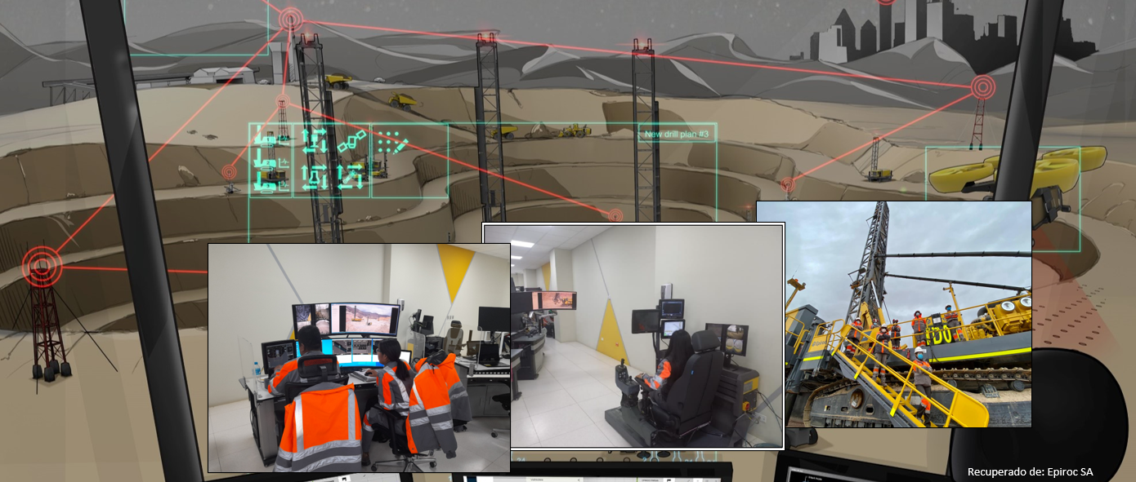

Figure 2: Integrated Operations Center for Drilling and Safety Component Recognition on the Pit Viper 351.

Figure 3: Supervisor of Autonomous Drilling and drill controllers at Quellaveco Mine.

On the other hand, considering information from the drilling process in conventional mines, the following benefits can be observed in terms of safety, productivity, precision, and maximized utilization:

Table 2: Epiroc Client Database for Conventional Mines (2024–2025).

* Improved fleet management: one controller can operate up to 3 autonomous drilling rigs.

Operational efficiency in terms of workforce improves by 66.67% when autonomous technology is implemented in place of manual operation.

1:3  
Operating ratio

* Reduction in idle time due to shift changes and weather conditions.
* Greater uniformity in drill pattern quality, optimizing subsequent blasting stages.
* Use of AI algorithms for performance analysis and ML tools to continuously optimize drill pattern accuracy.
* En términos de productividad, Quellaveco ha mantenido un nivel de calidad de pozos en términos de precisión x,y del 92% y z del 99%, lo cual genera un impacto positivo en la voladura y procesos aguas abajo.

Figure 4: Autonomous Drilling Historical Performance – Quellaveco Mine (Up to May 2025).

4.2 Safety Benefits:

* Zero lost-time incidents (LTI) related to drilling since automation.
* Elimination of exposure to dust, noise, and vibrations for operators.
* Removal of the operator from the line of fire (risk zone), reducing direct exposure to operational hazards.

0  
Accidentes 2025

4.3 Inclusion and Talent Development

* Training of over 15 workers in digital skills and remote operation.
* Inclusion of young women without prior mining experience as remote operators, promoting gender equity.
* The Quellaveco’s commitment to inclusion se ve reflejado en un 65% de presencia femenina en el team de perforación. These roles are supported by leadership development and multitasking training for remote controllers, reinforcing the digital capacity of the workforce.

Figure 5: Drill controller conducting autonomous drilling operations from the Integrated Operations Center.

* Creation of new job profiles such as remote operators, network technicians, and fleet monitoring specialists.
* In the case of the drill controller, their training emphasizes both technical and leadership skills, with empowerment to execute multiple autonomous drilling processes. Key competencies include multitasking with office software, delay management, coordination of operational interactions, and decision-making.

Figure 6: Drill controller conducting teleremoto drilling operations from the Integrated Operations Center.

* Upskilling initiatives include foundational courses in AI and ML concepts for supervisors and technical staff.

4.4 Remote Operation from an Integrated Operations Center (IOC)

* Operating from an Integrated Operations Center provides a comprehensive view of the entire value chain and its impact on the business as the final deliverable.
* It enables timely decision-making in response to any deviation that may affect downstream processes, always with a focus on the ultimate objective: the safe and efficient production of fine copper.

Figure 7: Integration of the Autonomous Drilling Process Across the Entire Business Chain at Quellaveco.

4.5 Technical Challenges

* Need for high-availability private Wifi network coverage in areas with complex topography.
* Interference from extreme weather conditions affecting GNSS sensors.
* Restrictions on the use of autonomous drilling in narrow sectors such as phase openings, platforms smaller than 40 m, slopes greater than 7%, crest spacing under 3.5 m, control zone spacing of 5.5 m, and burden of 5 m.
* Presence of water in blast holes limiting continuous operation.
* Ensure stable utilization of autonomous drilling technology to consistently achieve the expected quality of drilled holes as per design requirements.

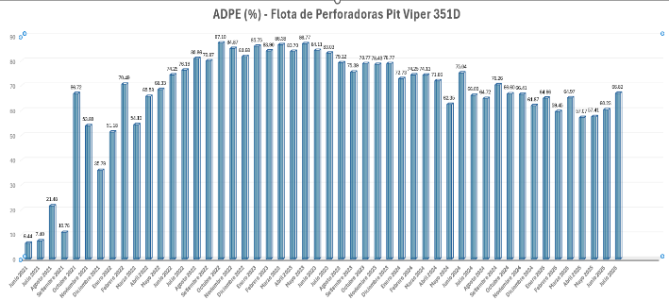

Figure 8: Historical Record of Autonomous Drill Usage at Quellaveco.

Drilling Sequence Behavior During Autonomous Operation:

Figure 9: Use of Drill Autonomy (AD2) vs. Average use for autoleveling (AL) and AutoNav.

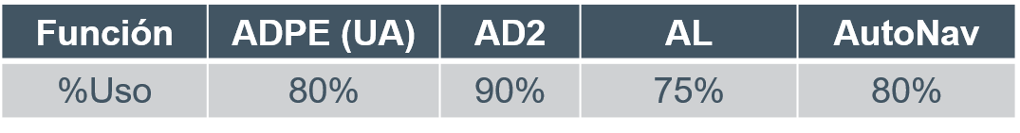

Table 3: Benchmark ADPE, AD2, AL and Autonv in autonomous drilling process.

* + High utilization of AD2, with a trend consistently above 80%.
  + Use of autonomy follows the trends seen with AL and AutoNav:
* AL is used 32% less compared to its peak in UA.
* AutoNav is used 30% less compared to its peak in UA.
* If AAQ aligns with the benchmark set by AL and AutoNav, autonomy usage would reach 80%.

Figure 10: Autonav real data vs benchmark.

Figure 11: Autonav diagnosis: out of working zone and out of obstacle zone.

The benchmark for Auto Navigation is 80% for sites with mature autonomy usage.

In 2025, the AutoNav percentage dropped to 21%, mainly due to non-compliance with virtual boundary distances, as evidenced by an increase in overrides outside the designated work zones.

Drill platform preparation and intervention by other equipment in the autonomous drilling zone also contribute to 65% of the decrease in AutoNav usage. This is reflected in the number of overrides caused by obstacles and the machine’s proximity detection system.

* Double-Bench and Angled Drilling:
  + Current drilling at a 16-meter depth results in higher costs compared to the 30-meter (double-bench) configuration.
  + The Pit Viper fleet dimensions limit operations in crest areas, requiring manual intervention by the drill controller.
  + Angled drilling is critical to enhance safety and efficiency in irregular terrain and elevated areas.
* Natural phenomena such as solar storms (scintillation) in southern Peru affecting GPS accuracy and interrupting autonomous operation.

To address this challenge, the implementation of R750 GPS receivers has been identified, contributing to:

Improved Precision and Connectivity

The R750 base station uses Maxwell™ 7 GNSS technology to track all visible GNSS constellations and signals, providing more reliable coverage to keep operations running.

With ProPoint™ technology, it delivers better performance and productivity in challenging environments. Its advanced signal filtering and error modeling provide enhanced protection against jamming, spoofing, and multipath, resulting in improved accuracy and reliability.

Temporary loss of connection to the primary correction source is now less of a concern thanks to xFill® and CenterPoint® RTX, which enable continued real-time kinematic (RTK) accuracy for up to five minutes after signal loss.

It allows constant connectivity and real-time worksite data updates. RTK corrections can be transmitted from a remote base via the integrated LTE modem and the Internet Base Station Service (IBSS). RTK corrections can also be received directly from Trimble VRS Now® or other NTRIP-based Internet correction services.

Trimble IonoGuard Technology – Ensuring GNSS Accuracy Amid Increasing Solar Activity

It is widely known that Earth's atmosphere directly affects GNSS signal reception, but solar activity also plays a significant role in GNSS signal stability.

The solar cycle peaks every 11 years, with the next expected peak in 2025, directly impacting GNSS signal delays and stability—potentially degrading positioning accuracy. This section explores the challenges GNSS users face and how Trimble’s IonoGuard technology mitigates these effects in receivers equipped with the Trimble ProPoint® engine.

IonoGuard in the Field – Mitigating Ionospheric Interference

This technology leverages advanced algorithms to mitigate all types of ionospheric disturbances affecting satellite signals, thereby ensuring greater reliability and accuracy in GNSS positioning.

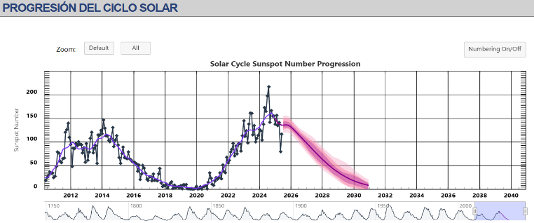

Figure 12: Solar Cycle Progression.

Figure 13: Analysis Between SPS 855 and R750 Receivers – Trimble.

Scintillation Mitigation Analysis Between Legacy Receivers and R750 Receivers with IONOGUARD – Case Studies with Epiroc Clients

At Quellaveco, we are beginning to monitor the performance of scintillation events.

R750 Receivers with IONOGUARD – Deployed in the Pit Viper 351D fleet

As part of a continuous improvement process at Quellaveco, the migration from SPS855/SPS555 receivers to the new R750 receivers (firmware version 6.28 with IONOGUARD) was carried out.

The configuration process included IONOGUARD activation to enable protection against ionospheric scintillation.

Figure 14: GNSS Satellite Visibility and Positioning Accuracy.

Currently, there is still no scintillation event data available since the migration was completed. Data collection is expected to begin in September 2025.

* ML-based fault detection systems are still in development and require more data for accurate predictive maintenance.

4.5 Organizational Challenges

* Cultural resistance to change from traditional operators.
* Initial difficulties in interoperability between platforms from different vendors (drilling equipment, management software, monitoring systems).

4.6 Lessons Learned

* Early participation of workers in the change process improves acceptance.
* Integration of automation should be planned from the mine project design stage.
* A highly skilled technical support and maintenance team in digital technologies is essential.
* Strict compliance with platform design is key for autonomous operability.
* AI and ML should be embedded from the outset to support adaptive learning and real-time analytics.

4.7 Next Steps and Improvement Opportunities

* Implementation of LTE Network to Improve Coverage in Remote or Confined Drill Platforms, in Line with Pit Deepening.
* Improve platform designs to facilitate autonomous operation in narrow or complex zones.
* Implement drones capable of night-time topographic surveys for more timely and accurate data.
* Fine adjustments in drill designs in crest zones to ensure accuracy.
* Develop sensors with extended range and complete proximity detection coverage.
* Apply machine learning algorithms to optimize drilling and blasting designs based on the specific objectives of each phase.
* Explore the potential of AI-driven digital twins for predictive modeling of drilling performance.
* Implementation of the Bit Changer for Safety and Productivity Purposes:
* Reduce la exposición del personal a riesgos al momento de cambiar brocas en los equipos.
* Disminuye significativamente el tiempo requerido para la actividad.

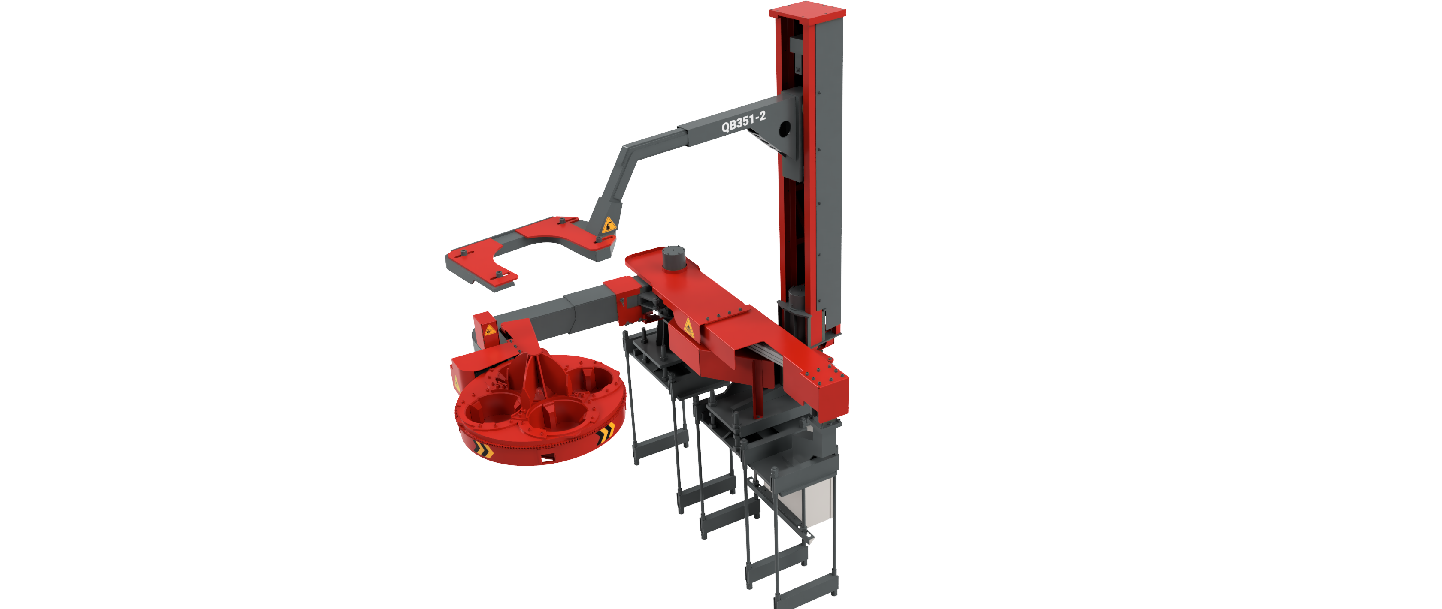

Figure 15: QB351-2 auto bit changer.

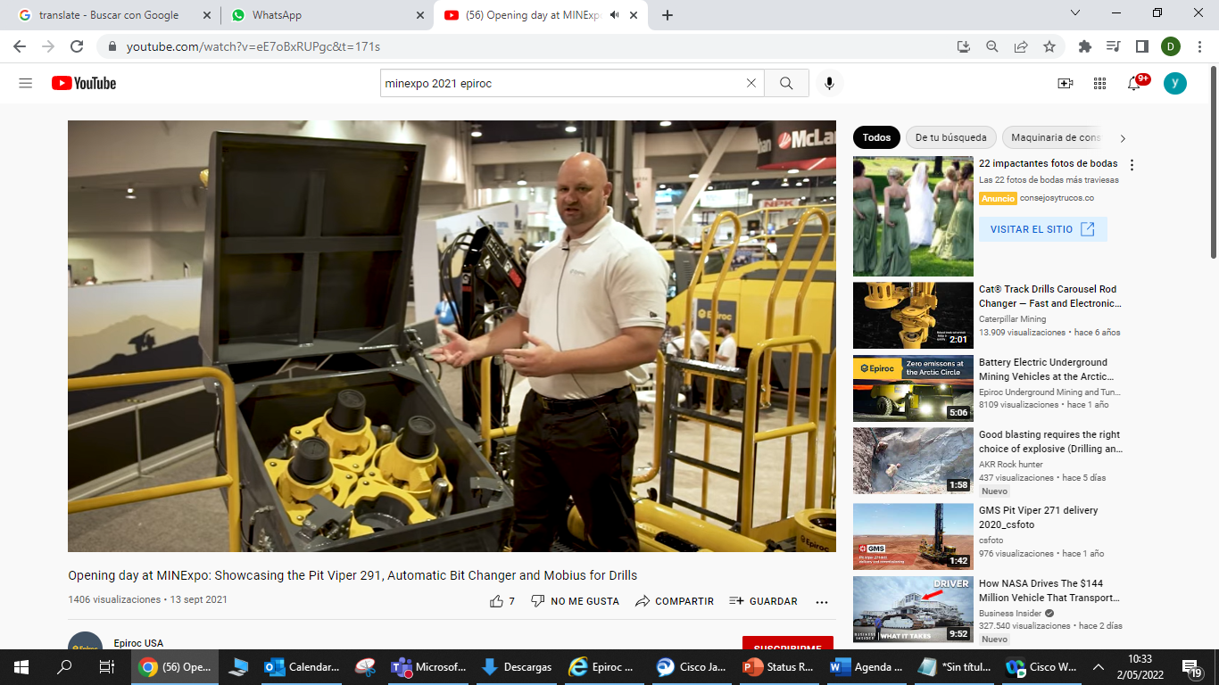

Figure 16: Drill bit storage for QB351-2 auto bit changer.

* **Kit de limpieza de láser:** Reducir la intervención en la limpieza de los láseres de detección de obstáculo
* **Migrar al Sistema CAP de Epiroc:** Con el CAP se podrá controlar tanto la flota SmartROC y Pit Viper desde un mismo lugar
* **Convertir la flota auxiliar a teleremoto y/o autónomo:** Optimizar tiempo y procesos en limpieza como habilitación de áreas de perforación.

**5. Conclusions**

* The implementation of autonomous drilling at Quellaveco demonstrates that achieving safer, more efficient, and inclusive mining is possible through integrated and collaborative strategies. Quellaveco's experience offers a replicable model tailored to the Latin American context, provided it includes careful planning, infrastructure investment, and human talent development. Progress toward autonomous operations must be accompanied by an ethical and sustainable approach that values both technology and the people who enable it.
* Looking ahead, the broader adoption of automation, artificial intelligence (AI), and machine learning (ML) is set to redefine the mining industry. These technologies are already improving safety, efficiency, and productivity across various operational stages—including the potential for applications in mine rescue and post-mining rehabilitation.
* Benefits extend beyond safety to include improved data accuracy and quality, reduced operating costs, enhanced environmental stewardship, and more informed decision-making. Nevertheless, several challenges remain on the path toward fully intelligent mining systems. Current limitations include the need for more advanced AI and ML models capable of adapting to dynamic environments, as well as the underdevelopment of automation solutions for post-mining processes such as land rehabilitation and closure activities.
* To overcome these barriers and drive innovation, continuous research and testing are essential. This includes real-world application of intelligent mine rescue systems, enhanced platform designs, and machine learning-driven optimization of drill and blast patterns. Future efforts must also ensure that the integration of new technologies aligns with the industry’s sustainability goals and environmental commitments.
* Ultimately, the mining industry stands at the threshold of a technological transformation. By embracing autonomous systems and investing in human–technology integration, mining operations can achieve not only greater operational efficiency but also a more responsible and resilient future—one where economic success is harmonized with social and environmental responsibility.

**6. Anexxes**

* + - A. Productivity comparison: Manual vs Autonomous drilling (PV351 & SR D65)
    - B. Operator gender composition chart
    - C. Automation maturity map (2022–2025)
    - D. Precision metrics (XY/Z)
    - E. Autonomous functions usage rates (AutoLevel, AutoNavigation, AutoDeLevel)
    - F. KPI W29 summary charts
    - G. Uso de Autonomía – AAQ 2025 (Epiroc – PV351).

**7. Referencias bibliográficas**

Kokkinis, T., Suoranta, R., Kärkkäinen, H., Dufva, M. 2024. Review of Automated Operations in Drilling and Mining. Machines, v. 12, p. 845–862.

Nebot, E., Huang, J., Pathak, K., Scheding, S. 2020. Surface Mining: Main Research Issues for Autonomous Operations. Proceedings of the International Symposium on Robotics Research (ISRR), v. 35, p. 114–128.

GMG Group. 2024. Guideline for the Implementation of Autonomous Systems in Mining. Global Mining Guidelines Group, v. 1, p. 1–74.

Saleem, M., Khan, M.A., Khalil, H., Shahid, A., Bacha, U. 2025. Automation and AI in Enhancing Mining Efficiency. Procedia Environmental Science, v. 49, p. 117–124.

Martínez, J. 2023. Platform Design for Autonomous Drilling in Peruvian Mines. Universidad Nacional de Ingeniería, v. 14, p. 77–93.

NASA. 2021. Space Weather Effects on GNSS Systems in South America. NASA Technical Brief, v. 6, p. 34–42.

BHP. 2022. Mining Automation: Lessons from Pilbara Operations. Company Technical Report, v. 3, p. 1–38.

Rio Tinto. 2023. Autonomous Drilling and Haulage Annual Report. Rio Tinto Internal Publication, v. 2, p. 1–55.

Global Mining Review. 2023. Women in Mining Tech: Breaking Barriers in Automation. Global Mining Review Magazine, v. 7, p. 66–72.

Anglo American. 2024. Digital Transformation at Quellaveco. Internal Document, v. 1, p. 1–15.

Pacheco, W. 2025. Perforación Autónoma y Teleremoto. Presentación Técnica – Anglo American Quellaveco, v. 1, p. 1–20.

Lucero, A.A. 2025. Drill and Blast at Quellaveco – Gender Inclusion, Safety and Precision KPIs. Anglo American Quellaveco Presentation, v. 1, p. 1–18.

Superintendencia de Perforación y Voladura. 2025. Weekly KPI Report W29 – Autonomous Drilling Operations. Anglo American Quellaveco, v. 1, p. 1–12.

Anglo American. 2025. Uso de Autonomía en Quellaveco: Reporte Operacional. Anglo American Quellaveco, v. 1, p. 1–16.

Anglo American. 2025. Uso de Autonomía – AAQ 2025. Epiroc Quellaveco, v. 1, p. 1–16.

**8. Ilustrations / Images / Tables**

* Figure 1: Drilling controller station with a view of the mine's drill rig location, drill pattern, drilling parameters, drilling sequencing, and bit change rig.
* Figure 2: Integrated Operations Center for Drilling and Safety Component Recognition on the Pit Viper 351.
* Figure 3: Supervisor of Autonomous Drilling and drill controllers at Quellaveco Mine.
* Figure 4: Autonomous Drilling Historical Performance – Quellaveco Mine (Up to May 2025).
* Figure 5: Drill controller conducting autonomous drilling operations from the Integrated Operations Center.
* Figure 6: Drill controller conducting teleremoto drilling operations from the Integrated Operations Center.
* Figure 7: Integration of the Autonomous Drilling Process Across the Entire Business Chain at Quellaveco.
* Figure 8: Historical Record of Autonomous Drill Usage at Quellaveco.
* Figure 9: Use of Drill Autonomy (AD2) vs. Average use for autoleveling (AL) and AutoNav.
* Figure 10: Autonav real data vs benchmark.
* Figure 11: Autonav diagnosis: out of working zone and out of obstacle zone.
* Figure 12: Solar Cycle Progression.
* Figure 13: Analysis Between SPS 855 and R750 Receivers – Trimble.
* Figure 14: GNSS Satellite Visibility and Positioning Accuracy.
* Figure 15: QB351-2 auto bit changer.
* Figure 16: Drill bit storage for QB351-2 auto bit changer.
* Table 1: Performance achieved at Quellaveco compared to manual operation.
* Table 2: Epiroc Client Database for Conventional Mines (2024–2025).
* Table 3: Benchmark ADPE, AD2, AL and Autonv in autonomous drilling process.

**9. Web publications**

* La visión digital de Anglo American para Quellaveco toma forma con la llegada de equipos de perforación autónomos de Epiroc.

<https://www.epiroc.com/es-pe/newsroom/2022/perforacion-autonoma-quellaveco-epiroc>

* Perforadoras autónomas para operaciones más seguras.

<https://peru.angloamerican.com/innovacion/future-smart-mining/perforadoras-autonomas-para-operaciones-mas-seguras.aspx>

* Perforación y voladura en Quellaveco: un proceso liderado por mujeres.

<https://peru.angloamerican.com/sustentabilidad/inclusion-y-diversidad/perforacion-y-voladura-en-quellaveco-un-proceso-liderado-por-mujeres.aspx>

* Anglo mira al futuro

<https://www.epiroc.com/es-ar/customer-stories/2023/anglo-eyes-the-future>

**Name:**

Andrea Akemi Lucero Verde

**About:**

I am a Mine Development Superintendent with over a decade of experience in open-pit mining operations. Currently leading strategic initiatives at Anglo American, I oversee road management, dust suppression (PM10), mining and hauling operations, and tire performance—areas critical to safety, efficiency, and sustainability.

My focus is on operational excellence through innovation. I’m passionate about identifying and implementing data-driven projects that go beyond the “fire line” of daily operations. I believe in implementing intelligent systems where people are safeguarded and empowered by technology.

**Education:**

Executive education:

1. Imperial Business analytics: from data to decisions (2025).
2. Data Science and AI for executives (2025).

Master:

1. Master of business administration (2016-2019)

Undergraduate studies:

1. Mining engineer (2005 – 2010)